Jurnal  Teknologi |  |  | Full Paper
Desulfurization of Heavy Naphtha with synthesized active carbon (PDAC) and impregnated (Cu₂Cl): Optimization, Kinetic, and Isotherm Studies  Fatima K.Hamza, Abbas K.Mohammad  Fatima K.Hamza, Al-Diwaniyah, Iraq  Abbas K.Mohammad, Al-Diwaniyah, Iraq  College of Engineering, Department of Chemistry, University of Al-Qadisiyah, Al-Diwaniyah, Iraq |  | Article history  Received  X Month 202Y  Received in revised form  XA Month 202Y  Accepted  XB Month 202Y  *Corresponding author  fatima.kadum.humza@qu.edu.iq  Co-author: abbas.shuaab@qu.edu.iq  Please provide an official organisation email of the corresponding author
Graphical abstract  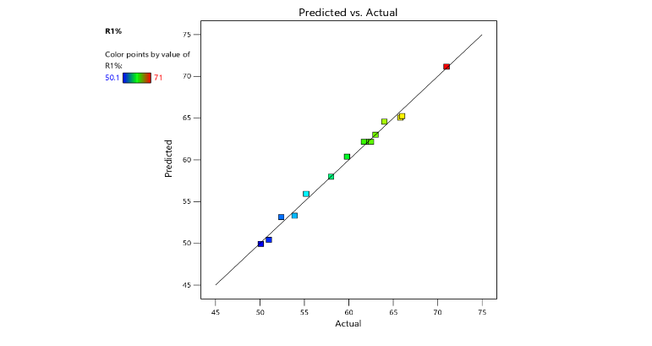 | Abstract  This research explores the adsorptive removal of sulfur from heavy naphtha using prepared activated carbon from Iraqi date pits (Phoenix dactylifera L. cv. Zahidi) (PDAC) and copper chloride-impregnated date pits activated carbon (Cu₂CI/PDAC). The adsorbent was optimized by Response Surface Methodology (RSM) using Box-Behnken Design to study the influence of temperature, contact time, and adsorbent dosage on the sulfur removal efficiency. The optimum conditions led to a maximum sulfur removal efficiency of 71% (31°C, 2.96 hr, and 0.0397 g/mL adsorbent). Kinetic studies revealed that sulfur adsorption followed the pseudo-second-order model, suggesting chemisorption as the adsorption mechanism, and equilibrium data were best fitted with Freundlich model of adsorption isotherms based on temperature. The research confirms that low-cost biomass-based activated carbon impregnated with Cu₂Cl is a viable and promising adsorbent to remove sulfur compounds from heavy naphtha, which helps in producing clean fuel and protects the environment.  Keywords: Heavy naphtha; Adsorptive desulfurization; PDAC; Response Surface Methodology; Kinetics; Isotherm models.
 | © 202@ Penerbit UTM Press. All rights reserved

1.0 INTRODUCTION

Petroleum fractions, particularly heavy naphtha, contain sulfur compounds that are significant environmental pollutants as they are oxidized to sulfur oxides (SO₂) during combustion, leading to acid rain, air pollution and catalyst poisoning [1, 2]. The world's increasingly stringent environmental regulations have increased the demand for ultra-deep desulfurization processes to supply cleaner fuels[1,3]. While traditional hydrodesulphurization processes are commercially mature, they are typically associated with high costs, harsh operating conditions and low yields for recalcitrant sulfur compounds such as thiophenic compounds[2,3]. Adsorptive desulfurization has gained popularity as an alternative method owing to its low energy consumption, ease-of-operation and selective removal of sulfur-containing compounds at mild conditions[4]. Activated carbon is a promising adsorbent due to its high specific surface area, well-developed pore structure, chemical inertness, and low cost[4]. In recent years, bio-based activated carbons have attracted special attention as environmentally-friendly adsorbents due to their use of renewable agricultural waste materials and low cost[4]. Iraq and other Middle Eastern nations have a significant amount of date pits, an agricultural waste

product, which is a cheap and sustainable raw material for the preparation of activated carbon due to its high carbon content. Activation with phosphoric acid can increase the carbon's porosity and surface functional groups, which boost the sulfur adsorption [4]. Moreover, the impregnation of various metals (e.g. copper chloride) can improve adsorption capacity by creating more adsorption sites and enhancing the interactions with sulfur compounds[5,6]. Design of experiments (DOE) using statistical methods such as Response Surface Methodology (RSM) and Box-Behnken Design are powerful methods to assess process variables and interactions with reduced experimental effort[7,8]. Recent local investigations on Iraqi refinery streams demonstrated that adsorptive desulfurization with locally sourced adsorbents is feasible, highlighting the need for sustainable fuel purification systems [9]. Hence, this study deals with the preparation, optimization, kinetic and thermodynamic studies of Cu₂Cl-loaded date pit activated carbon for the desulfurization of heavy naphtha, presenting an effective and sustainable method of preparing environmentally-friendly fuels locally.
- Kinetic models
Kinetic models are used to find the effectiveness of the adsorbent and the time needed to attain equilibrium. The most common models are:
  - Pseudo-First Order Model
This model was first introduced by Lagergren in 1898 and it suggests that the rate of adsorption is controlled by the availability of adsorption sites on the adsorbent's surface [10].
Linear Equation:
$$\text{ln}\left(q_{e}-q_{t}\right)=\text{ln}q_{e}-k_{1}t$$
Where: qe and qt: Amount of adsorbate at equilibrium and at time t (mg/g).
k₁: Pseudo-first order rate constant (min⁻¹).
  - Pseudo-Second Order Model
This model assumes that the adsorption is chemisorption, meaning that there are valence forces through the sharing or exchange of electrons between the adsorbent and adsorbate [11,12]
Linear Equation:
$$\frac{t}{qt}=\frac{1}{K_{2}q2e }+\frac{1}{qe}$$

Where: k₂: Pseudo-second order rate constant (g/mg·min).
In most liquid phase adsorption studies, this model has a very high correlation coefficient (R²).

- Isotherm models
These models refer to the equilibrium relationship between the concentration of the substance in solution and its amount on the adsorbent at a constant temperature[13].
  - Langmuir Isotherm
Model This is based on the adsorption of a single layer of molecules on a uniform surface, with no interaction between adsorbed molecules [14].
Linear Equation:
$$\frac{C_{e}}{q_{e}}=\frac{1}{K_{L}q_{m}}+\frac{C_{e}}{q_{m}}$$
Where: Ce: Concentration of the substance at equilibrium (mg/L).
q_{m}: Maximum monolayer adsorption capacity (mg/g).
K_{L}: Langmuir constant (related to energy of adsorption).
  - Freundlich Isotherm
Model This empirical model is used to describe the adsorption on a heterogeneous surface and allows formation of multilayers [15].
Linear Equation:

$$\text{log}q_{e}=\text{log}K_{F}+\frac{1}{n}\text{log}C_{e}$$
$\text{log}q_{e}=\text{log}K_{F}+\frac{1}{n}\text{log}C_{e}$
Where: K_{F}: Freundlich constant related to the capacity of adsorption.
1/n: Factor related to the intensity of adsorption and the heterogeneity of the surface
.

- MOTHODLOGY
  - Materials and Methods
The date pits used in this research were sourced from the date palm (Phoenix dactylifera L. cv. Zahidi) located on local farms in Diwaniyah, Iraq. The samples were thoroughly washed with distilled water to remove any remaining impurities, then sun-dried for three days, followed by oven-baking at 110°C for three hours. The dried material was then ground and sieved to obtain particles ranging in size from 150 to 300 micrometers.

A type of adsorbent, acid-activated carbon (PDAC), was synthesized. For carbonization, 100 grams of the produced PD date pits were heated at 600°C for two hours under a continuous nitrogen flow rate of 3 liters per minute.

45 g of pre-carbonized material was impregnated with 300 mL of 4 M phosphoric acid solution (carbon-to-solution ratio 1:6.7 w/v). The mixture was stirred for 30 minutes and then left to infuse for 24 hours before drying. The impregnated samples were activated at 600 °C for 2 hours in a nitrogen atmosphere, then rinsed with deionized water to neutral pH and dried at 110 °C for 6 hours.

The activated carbon was impregnated with copper(II) chloride solution, prepared by dissolving 0.3 g of CuCl₂ in 40 mL of distilled water per 5 g of activated carbon. The impregnation ratio was 6 wt% (CuCl₂/carbon). The mixture was stirred at 60 °C for 5 hours to ensure uniform distribution of the metallic precursor across the entire carbon network. The suspension was then filtered, and the resulting solid precipitate was dried at 100 °C and calcined for 2 hours in a nitrogen atmosphere to prepare mineral-loaded activated carbon. Adsorption experiments were conducted using heavy naphtha produced at the Diwaniyah refinery, which had an initial sulfur content of 1200 ppm. The mineral-loaded activated carbon was the adsorbent used in the batch adsorption tests as show in figure (1). Quantities of adsorbent (2, 3, and 4 grams) were added to 100 mL of naphtha, and the mixtures were analyzed at different temperatures (20, 30, and 40 °C). The mixtures were mixed under controlled conditions, and liquid samples were withdrawn at specified time intervals. The amount of residual sulfur was determined to measure the desulfurization efficiency. To ensure the accuracy of elemental measurements, the sulfur content after adsorption was determined using X-ray fluorescence spectroscopy (XRF) )NEXQC,Rigaku Corporation,Japan). The adsorption kinetics were analyzed using pseudo-first-order (PFO) and pseudo-second-order (PSO) kinetic models to explain the adsorption mechanism and identify the phases controlling its rate. The kinetic parameters were determined using the linear formulas of the different models and evaluated using correlation coefficients (R²).
The experimental data were fitted to the Langmuir and Freundlich isotherm models to describe the equilibrium adsorption phenomenon. The parameters of the models were determined from linear plots and correlation coefficients (R²).

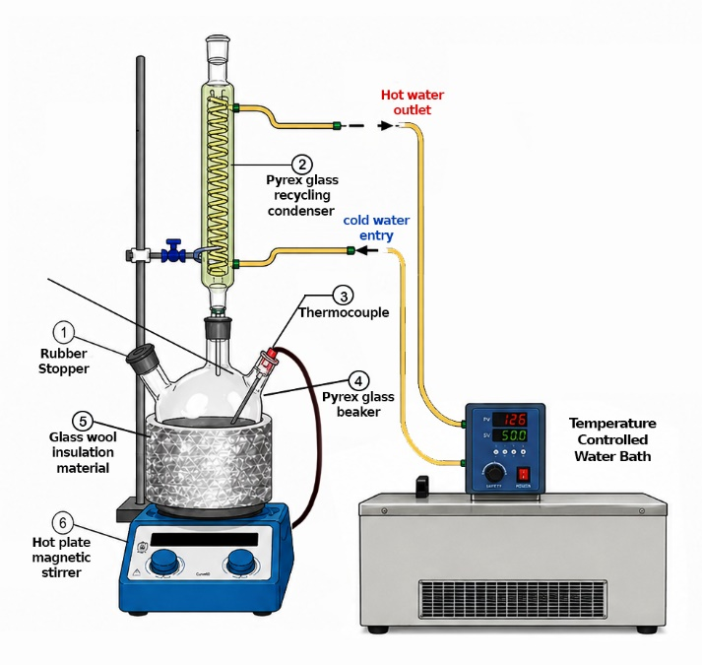

Figure (1): the adsorption process apparatus

  - Process parameter optimization
In order to investigate the influence of process variables and their interaction in the process of adsorptive desulfurization, a series of experiments was performed, varied the key operating variables; temperature, contact time and adsorbent dosage. The sulfur content of the feed was maintained at 1200 ppm using heavy naphtha from Al-Diwaniyah refinery. The Box-Behnken Design (BBD) experimental design involved 15 experiments with three independent variables (temperature (A), contact time (B), adsorbent loading (C) Three levels (low, medium and high) of the variables were investigated: 20-40 C, 1-3 hours and 0.02-0.04 g ml-1, for temperature, contact time and adsorbent dosage, respectively. The design in Table (1) is a combination of factorial and repeated center points (runs 2, 6 and 13) and is used to estimate experimental error and the reproducibility of the model. The central point (30 C, 2 h, 0.03 g mL -1) is the center point and represents the average of all variables and it is used to check the curvature of the response surface.

Std | Run | Factor 1 | Factor 2 | Factor 3
 |  | A:Temp. | B:Time | C:Conc.
 |  | C | hour | gm/ml
3 | 1 | 20 | 3 | 0.03
14 | 2 | 30 | 2 | 0.03
8 | 3 | 40 | 2 | 0.04
11 | 4 | 30 | 1 | 0.04
2 | 5 | 40 | 1 | 0.03
15 | 6 | 30 | 2 | 0.03
1 | 7 | 20 | 1 | 0.03
12 | 8 | 30 | 3 | 0.04
9 | 9 | 30 | 1 | 0.02
6 | 10 | 40 | 2 | 0.02
7 | 11 | 20 | 2 | 0.04
4 | 12 | 40 | 3 | 0.03
13 | 13 | 30 | 2 | 0.03
10 | 14 | 30 | 3 | 0.02
5 | 15 | 20 | 2 | 0.02
The varying of the experimental conditions in the experiments helps in assessing the main effects and interaction effects of the variables. Runs 10 and 15 assess the effect of temperature with constant contact time and dosage of the adsorbent, while run 3 and 11 assess the interaction effect of extreme temperatures and dosage with a constant contact time. This systematic design allows the development of a quadratic model for the adsorption-desulfurization process and in the determination of optimum conditions with lesser number of experiments than the full factor design.

- Results and ANLAYSIS
  - RSM statistical analysis and results of the experiment
The RSM is a statistical method that was included in the experimental design to determine the effect of process parameters (independent variables) on a single response variable or multiple variables. (dependent variables). RSM effectively reduces the amount of experiments required to be conducted and it takes into account the interactions between the parameters [7].The desulfurization of heavy naphtha was performed in two stages by 15 batch tests. of different process parameters. These are presented in Table 2. The desulfurization efficiencies were determined with actual and predicted values. There was a good level of agreement between the actual and estimated results as shown in Figure 2. Desulfurization efficiencies were calculated by Design-Expert 13 software[16]. to determine the relationship between the percent desulfurization and the process parameters. The final quadratic equations which were the results of analysis are as follows:

R1%=62.17+0.5125A+4.05B+6.56C+1.83AB-0.85AC+0.025BC-2.83A²-0.6583B²-0.9833C² (5)
In which, R1% represents the desulfurization efficiency of heavy naphtha and (A, B, C) represent, respectively: A, B and C represent the temperature, time and amount of adsorbent used per 100 ml of heavy naphtha, respectively. The interaction effects of the model parameters are represented by AB, AC, and BC, and A2, B2 and C2 represent the quadratic constraints of the process parameters. The signs of the coefficients in Equation (5) suggest the direction of the effect of each process parameter. A positive coefficient represents a positive or additive effect, while a negative coefficient represents a negative or subtractive effect. The influence of each variable is determined by the overall effect of its linear, interaction and quadratic components[8].
Table (2): Experimental design values of response variables for the removal percentage of predicted and actual values
 | Factor 1 | Factor 2 | Factor 3 | Removal %
Run | A:Temp. | B:Time | C:Conc.
 | C | hour | gm/ml | Actual Value | Predicted Value
1 | 20 | 3 | 0.03 | 59.8 | 60.39
2 | 30 | 2 | 0.03 | 62.5 | 62.17
3 | 40 | 2 | 0.04 | 64 | 64.58
4 | 30 | 1 | 0.04 | 63 | 63.01
5 | 40 | 1 | 0.03 | 53.9 | 53.31
6 | 30 | 2 | 0.03 | 61.7 | 62.17
7 | 20 | 1 | 0.03 | 55.2 | 55.94
8 | 30 | 3 | 0.04 | 71 | 71.16
9 | 30 | 1 | 0.02 | 50.1 | 49.94
10 | 40 | 2 | 0.02 | 52.4 | 53.15
11 | 20 | 2 | 0.04 | 66 | 65.25
12 | 40 | 3 | 0.03 | 65.8 | 65.06
13 | 30 | 2 | 0.03 | 62.3 | 62.17
14 | 30 | 3 | 0.02 | 58 | 57.99
15 | 20 | 2 | 0.02 | 51 | 50.43

  - Analysis of variance
Variance partitioning with sources of variance allowed an assessment of the suitability of the Box-Benkhen design [17]. Fisher's F-test was used to conduct an analysis of variance (ANOVA) to determine the significance of the coefficients[7]. The F-values and P-values for sulfur adsorption are shown in Table 3. The table shows the degrees of freedom, sum of squares, mean squares, F-value (Fisher's) and P-value. The P-test is carried out to check the F-value is high enough to affirm the statistical significance between the different statistical variables. The significance of the coefficient usually increases with decreasing P-value, but the significance of a factor increases with increasing F-value [8].The model boundaries were considered significant if P-values were less than 0.05 and non-significant if P-values were greater than 0.1[7].
Table 3 presents the ANOVA model for heavy naphtha desulfurization. The analysis of variance (ANOVA) model demonstrates a statistical significance with an F-value of 73.78 and a p-value below 0.0001. As seen in Table 4, The standard deviation is 0.8904. The R² value is 0.9925, the adjusted R² value is 0.9791, and the coefficient of variation (CV) is 1.49%, signifying an appropriate accuracy of 29.1946.

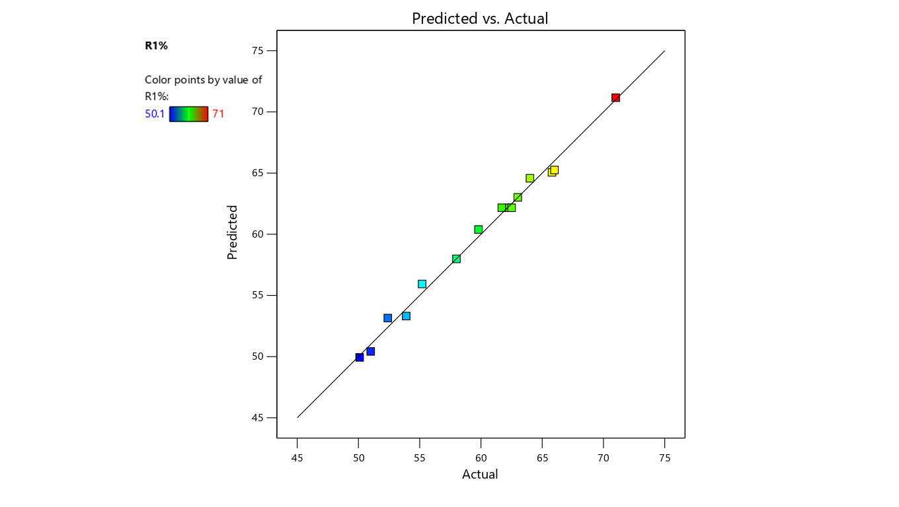
Figure (2): Plot of predicted vs. actual for % sulfur Removal

Table (3): ANOVA of response surface quadratic model for %sulfur Removal
_{Source} | _{Sum of Squares} | _{df} | _{Mean Square} | _{F-value} | _{p-value}
_{Model} | _{526.44} | ₉ | _{58.49} | _{73.78} | _{< 0.0001}
_{A-Temp.} | _{2.1} | ₁ | _{2.1} | _{2.65} | _{0.1645}
_{B-Time} | _{131.22} | ₁ | _{131.22} | _{165.51} | _{< 0.0001}
_{C-Conc.} | _{344.53} | ₁ | _{344.53} | _{434.56} | _{< 0.0001}
_{AB} | _{13.32} | ₁ | _{13.32} | _{16.8} | _{0.0094}
_{AC} | _{2.89} | ₁ | _{2.89} | _{3.65} | _{0.1145}
_{BC} | _{0.0025} | ₁ | _{0.0025} | _{0.0032} | _{0.9574}
_{A²} | _{29.64} | ₁ | _{29.64} | _{37.39} | _{0.0017}
_{B²} | _{1.6} | ₁ | _{1.6} | _{2.02} | _{0.2146}
_{C²} | _{3.57} | ₁ | _{3.57} | _{4.5} | _{0.0873}
_{Residual} | _{3.96} | ₅ | _{0.7928}
_{Lack of Fit} | _{3.62} | ₃ | _{1.21} | _{6.96} | _{0.1283}
_{Pure Error} | _{0.3467} | ₂ | _{0.1733}
_{Cor Total} | _{530.4} | ₁₄

Table (4): Summary of regression values for % sulfur Removal
Std. Dev. | Mean | C.V. % | PRESS | R² | Adjusted R² | Predicted R² | Adeq Precision
0.8904 | 59.78 | 1.49 | 58.66 | 0.9925 | 0.9791 | 0.8894 | 29.1946

  - Response surface and contour plots for Desulfurization of Heavy Naphtha
the presented 3D response surface and 2D contour plots that demonstrate the influence of various parameters on the desulfurization efficiency (R1%) of heavy naphtha[9]. Such graphs are critical towards understanding conditions of ideal functioning[8].
In Figure (3), the desulfurization efficiency (R1%) of heavy naphtha was considerably improved by increasing the reaction temperature and time, resulting in a greater than 71% removal of sulfur. The response surface and contour plots demonstrate a synergistic effect between temperature and time, where maximum sulfur removal occurs at moderate temperatures and longer times. This trend can be explained by the enhanced mass transfer and kinetics at optimum operating conditions. This observation was also made by [2], who showed that temperature and contact time are important factors for enhancing deep desulfurization of fuel streams. Similarly, [3] report that improved reaction conditions also enhance sulfur removal from heavy streams. In addition, [1] highlighted that Response Surface Methodology (RSM) is a powerful statistical technique to determine and optimize desulfurization.
The interaction of temperature (A) and adsorbent concentration (C) on the sulfur removal (R1%) of heavy naphtha are shown in Figure (4). The response surface and contour plots show that the optimal increase in both temperature and adsorbent concentration had a profound effect on sulfur removal efficiency, such that R1% improved from almost 50% to over 71%. Increasing adsorbent concentration increased the number of active sites, and increasing the temperature improved mass transfer and reaction rates, leading to better desulfurization. Nearly complete sulfur removal was achieved at medium-to-high temperature and maximum concentration[2 ,3, 1].
The response surface plot and contour plot in Figure (5) illustrates the interaction between reaction time (B) and adsorbent concentration (C) on the desulfurization efficiency (R1%) of heavy naphtha. It was found that higher reaction time and adsorbent concentration significantly enhanced sulfur removal, with R1% increasing from almost 50% at the low levels to more than 71% at the high levels. Increasing reaction time allowed more time for sulfur compounds to interact with the active sites of the adsorbent, and increasing adsorbent concentration provided a larger surface area for the sulfur species to adsorb. The high positive interaction between these factors suggests that increasing both of them is critical to maximize sulfur removal efficiency[2 ,3, 1].

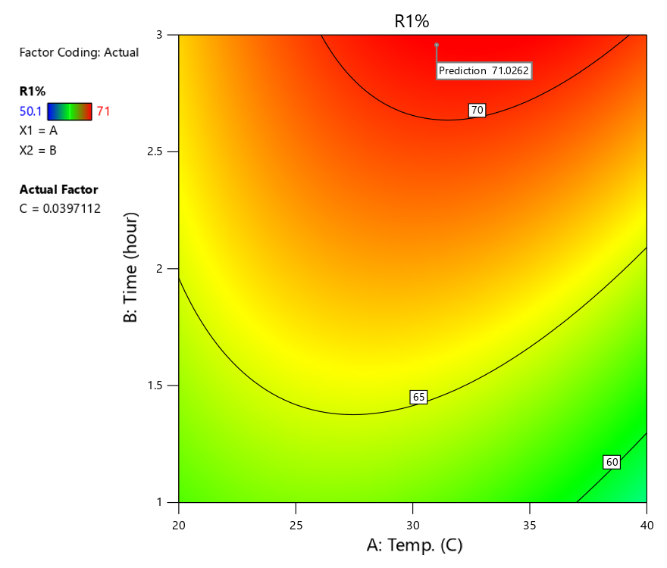

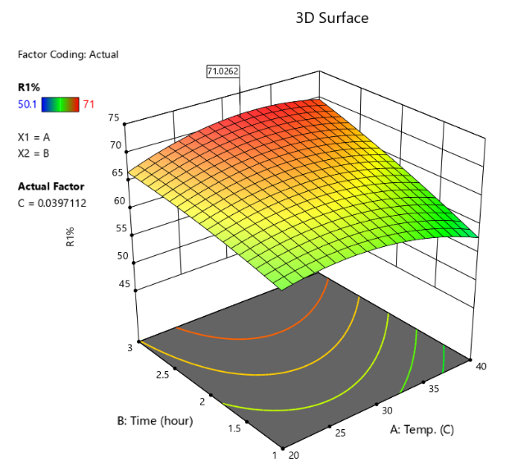
Figure (3) 3D and 2D plots of effect of Temperture and time on R1%

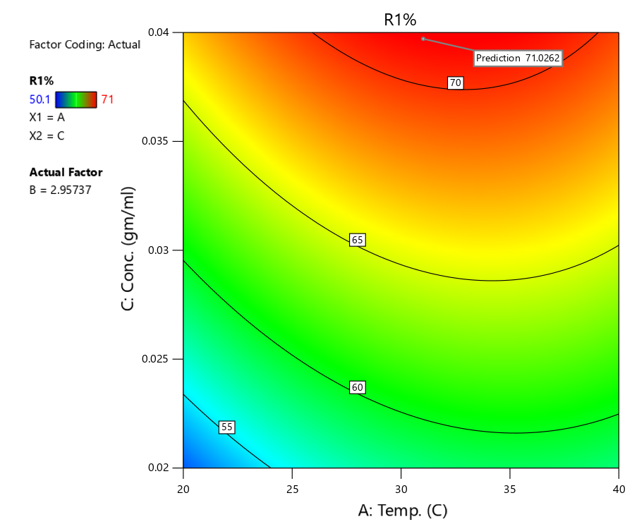

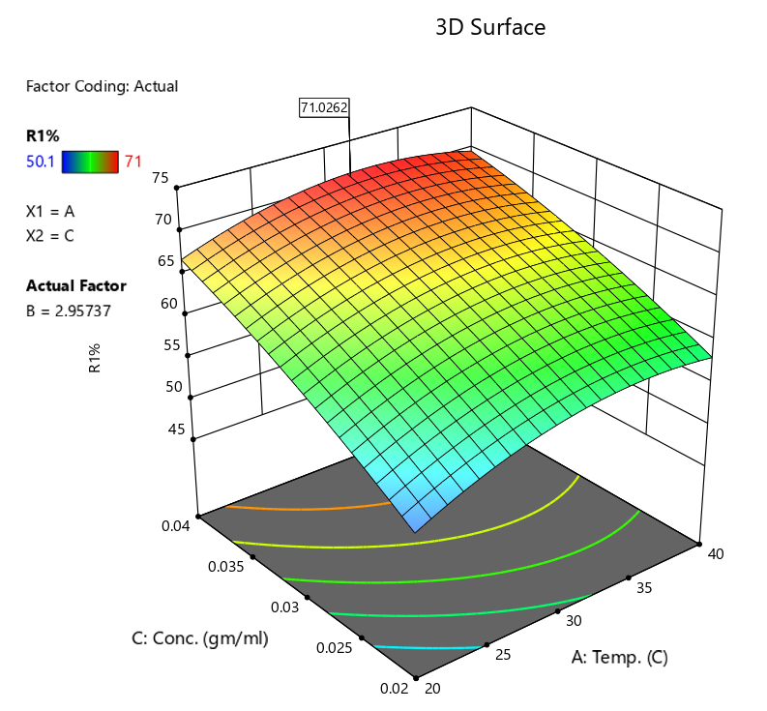

Figure (4): 3D and 2D plots of effect of Time and conc. on R1%
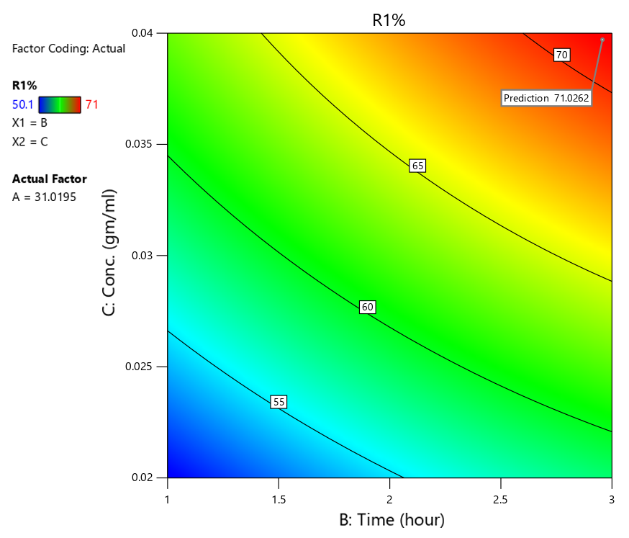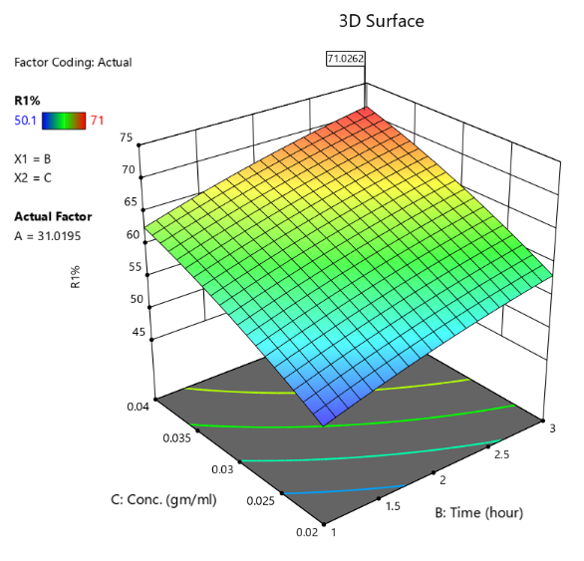
Figure (5) 3D and 2D plots of effect of Temperture and conc. on R1%

Table (5): Process parameters that gave the optimum removal efficiency
Parameters | Temperture(C) | Time(hr) | Con.of AC (mg/ml) | % Sulfur Removal
Optimum value | 31 | 2.9573 | 0.03971 | 71%

  - Fitting of Kinetic Models
In this study, the kinetics of the sulfur compounds from heavy naphtha onto the prepared adsorbent were determined under the best conditions. The adsorption kinetics were evaluated using the pseudo-first-order (PFO) and pseudo-second-order (PSO) kinetic models because of their simplicity and widespread use in understanding the adsorption process. The PFO model, suggested by Laguerre, is typically associated with physisorption, where the rate of adsorption depends on the availability of the adsorption sites[18]. However, the PSO model assumes that chemisorption is the rate-controlling step, which involves the sharing or exchange of electrons between adsorbent and sulfur compounds, thus providing a detailed description of the adsorption process[11].

Figure (6): Rate of adsorption of sulfur on PDAC.

As shown in the figure (6), the adsorption capacity (qt) rapidly grew within the first 1.5 hours and then reached equilibrium. The equilibrium adsorption capacity dramatically reduced with the rise in temperature, in which the maximum sulfur uptake occurred at 30 °C. This suggests that the adsorption of sulfur compounds on the activated carbon is an exothermic reaction. Our results are in line with those reported on adsorptive desulfurization of petroleum fractions, which indicate that increasing the temperature results in a higher desorption rate, which in turn lowers the adsorption capacity [5,6].

Figure (7). first order kinetic model for the adsorption of sulfur on PDAC at different Temperature

from the linear plots of ln(qe - qt) against time in figure (7)|. The results showed that the rate constant (k₁) was highest at 30 °C (0.6029 hr⁻¹), followed by 40 °C (0.4514 hr⁻¹) and 20 °C (0.1941 hr⁻¹). But the low values of the correlation coefficient (R² = 0.0917-0.5263) suggest that the pseudo-first-order model is not a good fit for the kinetics of the removal of sulfur. This implies that the adsorption process may be controlled by other mechanisms, such as chemisorption or intra-particle diffusion, which are better represented by other kinetic models [5,6].

Figure (8). second order kinetic model for the adsorption of sulfur on PDAC at different
Temperature

The pseudo-second-order model was also applied to the adsorption kinetics, with t/qt plotted against time. As displayed in the figure (8), this model showed a very good fit to the experimental data for all the temperatures with correlation coefficients (R²) above 0.992. The R² value (0.9976) was the highest at 30°C as show in table (6) , indicating that the sulfur adsorption from heavy naphtha onto activated carbon is a pseudo-second-order process. This high correlation indicates that the rate-limiting step is chemisorption, which means the binding forces are valence forces through sharing or exchanging electrons between the adsorbent and the adsorbate. In addition, the calculated value of the equilibrium capacity (qe) using the reciprocal of the slope was found to be highest at 30°C, thereby confirming that 30°C is the most suitable temperature for desulfurization[5,6].

Table (6) : The values ​​of R² and K for pseudo-second-order model
Temp. °C | The pseudo-second-order model
 | R² | K₂
20 | 0.9953 | 0.4843
30 | 0.9976 | 0.6552
40 | 0.9927 | 0.3985

  - Fitting of Isotherm Models
The equilibrium isotherm data of the sulfur content in the naphtha and the adsorption on the activated carbon were described by the Langmuir and Freundlich models. The Langmuir model is based on monolayer adsorption on a surface with a finite number of homogeneous sites, whereas the Freundlich model is based on multi-layer adsorption on a heterogeneous surface. The separation factor (RL) and the Freundlich constant (1/n) were determined to assess the feasibility of the adsorption process, which suggests that the activated carbon has a good affinity for sulfur compounds under the experimental conditions [4,9].

Figure (9). Langmuir adsorption isotherm model for sulfur adsorbed on the PDAC (at temperatures (20,30,40) °C.
The application of the Langmuir model to the desulfurization of heavy naphtha at various temperatures (20, 30 and 40 °C) is shown in Figure (9). The results demonstrated that at 20 °C, the model showed the highest correlation coefficient (R² = 0.9998), which means that the adsorption process is based on monolayer adsorption, where the surface is assumed to be energetically homogeneous. The maximum adsorption capacity (q) was calculated from the inverse slope and it was found that it decreased with increasing temperature and was highest at 20 °C. At 40 °C, the correlation coefficient (R² = 0.0001) was significantly lower, showing that the Langmuir model is inappropriate for describing the process at higher temperatures, and that the mechanism may change to a more complex system where surface homogeneity is not required[19].

Figure (10). Freundlich adsorption isotherm model for sulfur adsorbed on the PDAC (at temperatures (20,30,40) °C.
The figure (10) describes the Freundich linear model of adsorption, where the results indicate a good agreement between the model and experimental data of all the temperatures studied with the correlation coefficient (R²) close to one (0.9983 to 1.0). This indicates the "heterogeneity" of the surface of the activated carbon prepared with phosphoric acid and multilayer adsorption. The values ​​of the adsorption intensity coefficient (n) have been calculated from the inverse slope (1/n) values and were found to be in the range (1.002-1.151) as shown in table (7) , which are all greater than one, suggesting that the adsorption of sulfur compounds on activated carbon is favourable under the experimental conditions. The proximity of the value of 1/n to one also suggests a uniform distribution of the energy of the active sites on the surface of the adsorbent[20].
Table (7) : The values ​​of R² ,n and K_{f} for Freundlich adsorption isotherm model
Temp. °C | Freundlich adsorption isotherm model
 | R² | K_{f} | n
20 | 0.9989 | 0.0732 | 1.0419
30 | 1 | 0.1369 | 1.1516
40 | 0.9983 | 0.05409 | 1.0021

- Conclution
Activated carbon (PDAC) impregnated with Cu₂Cl as an adsorbent for desulfurization of heavy naphtha and proved successful in the process. The response surface methodology (RSM) approach was used effectively to determine the optimal operating conditions, leading to 71% maximum sulfur removal efficiency under mild operating conditions. The kinetic study validated the pseudo-second-order model for sulfur adsorption, suggesting that chemisorption was the dominant adsorption mechanism. The isotherms indicated beneficial sulfur sorption with Freundlich model appropriately describing the multilayer sorption mode as a function of temperature.
This study underscores the potential of agricultural biomass waste, such as date pits, as a valuable source of adsorbents for petroleum refining, providing a cost-effective and eco-friendly alternative to traditional desulfurization processes. This process not only aids in the production of cleaner fuels but also facilitates waste utilization and resource sustainability in biomass-rich areas. Future research could explore adsorbent regeneration, scalability, and commercialization to enhance this technology.

Referances :
[1] V. C. Srivastava, “An evaluation of desulfurization technologies for sulfur removal from liquid fuels,” Rsc Adv., vol. 2, no. 3, pp. 759–783, 2012.
[2] C. Song, “An overview of new approaches to deep desulfurization for ultra-clean gasoline, diesel fuel and jet fuel,” Catal. Today, vol. 86, no. 1–4, 2003, doi: 10.1016/S0920-5861(03)00412-7.
[3] I. V Babich and J. A. Moulijn, “Science and technology of novel processes for deep desulfurization of oil refinery streams: a review☆,” Fuel, vol. 82, no. 6, pp. 607–631, 2003.
[4] M. O. Azeez and S. A. Ganiyu, “Review of biomass derived-activated carbon for production of clean fuels by adsorptive desulfurization: Insights into processes, modifications, properties, and performances,” Arab. J. Chem., vol. 16, no. 10, p. 105182, 2023.
[5] H. Alalwan, “Catalytic oxidative and adsorptive desulfurization of heavy naphtha fraction,” Korean Chem. Eng. Res, 2019, doi: https://doi.org/10.9713/kcer.2019.57.2.1.
[6] Y. A. Abd Al-Khodor and T. M. Albayati, “Adsorption desulfurization of actual heavy crude oil using activated carbon,” Eng. Technol. J., vol. 38, no. 10A, pp. 1441–1453, 2020.
[7] D. C. Montgomery, Design and analysis of experiments. John wiley \& sons, 2017.
[8] R. H. Myers, D. C. Montgomery, and C. M. Anderson-Cook, Response surface methodology: process and product optimization using designed experiments. John Wiley \& Sons, 2016.
[9] A. Qasim and H. H. Alwan, “Adsorptive desulfurization of Iraqi light naphtha using calcite and modified calcite,” Iraqi J. Chem. Pet. Eng., vol. 25, no. 1, pp. 83–93, 2024.
[10] S. Lagergren and others, “About the theory of so-called adsorption of soluble substances,” 1898.
[11] Y.-S. Ho and G. McKay, “Pseudo-second order model for sorption processes,” Process Biochem., vol. 34, no. 5, pp. 451–465, 1999.
[12] E. D. Revellame, D. L. Fortela, W. Sharp, R. Hernandez, and M. E. Zappi, “Adsorption kinetic modeling using pseudo-first order and pseudo-second order rate laws: A review,” Clean. Eng. Technol., vol. 1, p. 100032, 2020.
[13] S. Kalam, S. A. Abu-Khamsin, M. S. Kamal, and S. Patil, “Surfactant adsorption isotherms: A review,” ACS omega, vol. 6, no. 48, pp. 32342–32348, 2021.
[14] I. Langmuir, “The adsorption of gases on plane surfaces of glass, mica and platinum.,” J. Am. Chem. Soc., vol. 40, no. 9, pp. 1361–1403, 1918.
[15] Z. Jin, X. Wang, Y. Sun, Y. Ai, and X. Wang, “Adsorption of 4-n-nonylphenol and bisphenol-A on magnetic reduced graphene oxides: a combined experimental and theoretical studies,” Environ. Sci. \& Technol., vol. 49, no. 15, pp. 9168–9175, 2015.
[16] R. Koliqi, P. Breznica, A. Daka, and B. Koshi, “Application of Design of Expert software for evaluating the influence of formulation variables on the encapsulation efficacy, drug content and particle size of PEO-PPO-PEO/Poly (DL-lactide-co-caprolactone) nanoparticles as carriers for SN-38,” Med. Pharm. Reports, vol. 94, no. 4, p. 483, 2021, doi: 10.15386/mpr-1831.
[17] H. A. Shamkhi, A. D. Z. Albdiri, F. A. Jabir, and D. Petruzzelli, “Removal of Pb2+, Cu2+, and Cd2+ ions from a saline wastewater using emulsion liquid membrane: applying response surface methodology for optimization and data analysis,” Arab. J. Sci. Eng., vol. 47, no. 5, pp. 5705–5719, 2022.
[18] K. Y. Foo and B. H. Hameed, “Insights into the modeling of adsorption isotherm systems,” Chem. Eng. J., vol. 156, no. 1, pp. 2–10, 2010.
[19] J. Rouquerol, F. Rouquerol, P. Llewellyn, G. Maurin, and K. Sing, Adsorption by powders and porous solids: principles, methodology and applications. Academic press, 2013.
[20] G. I. Danmaliki, T. A. Saleh, and A. A. Shamsuddeen, “Response surface methodology optimization of adsorptive desulfurization on nickel/activated carbon,” Chem. Eng. J., vol. 313, pp. 993–1003, 2017.

